**NI myDAQ Information:**

Plug in the myDAQ with USB cable into one of the USB ports on the laptop

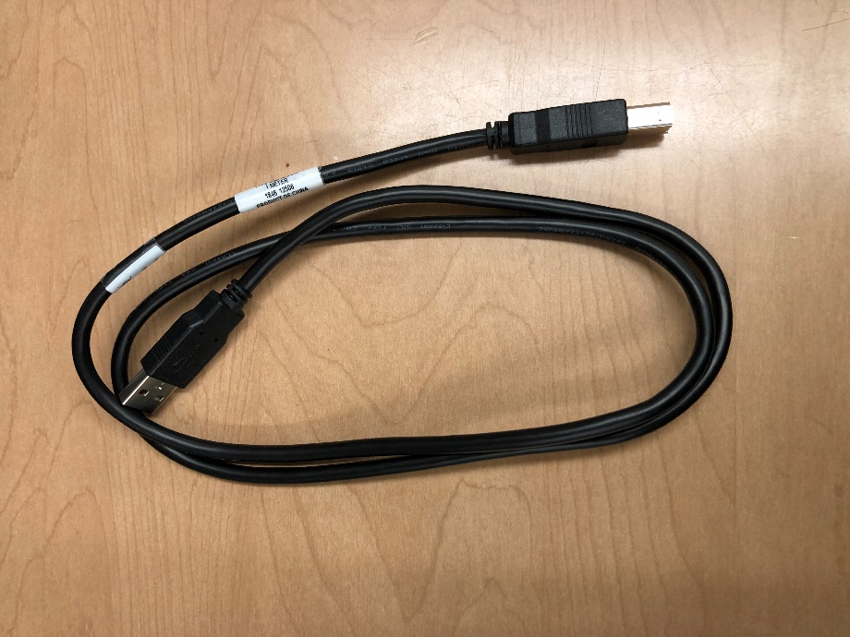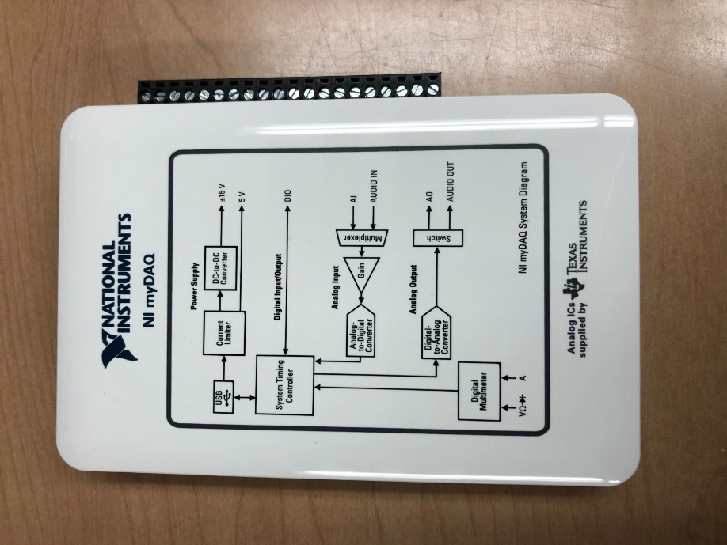

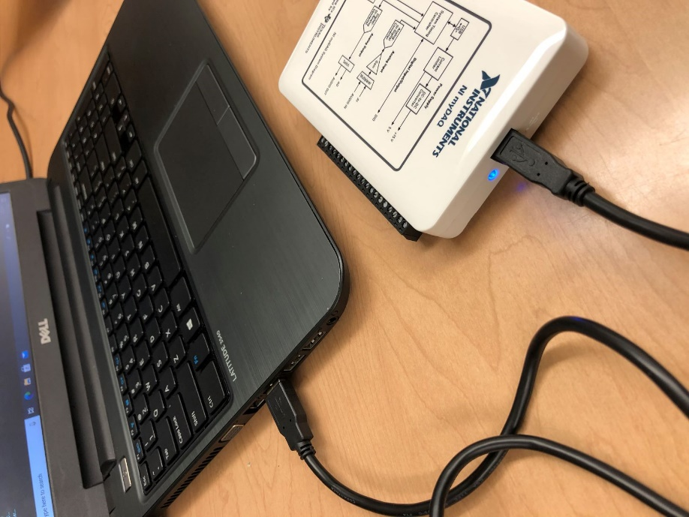

You should see blue light in the myDAQ near the USB connector port on the white myDAQ block

This action of connecting the USB cable into the computer from the myDAQ should auto start the application, NI Device Monitor.

It may detect myDAQ1 or myDAQ2, depends on the unit you are using.

Be sure to keep up with this subtlety (of myDAQ1 or myDAQ 2 ) as you may need to adjust for this in the MATLAB example.

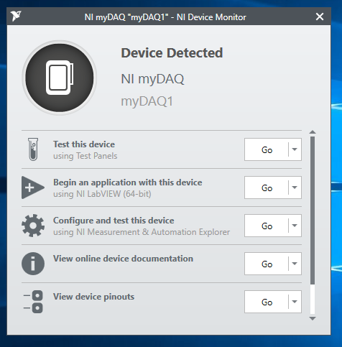

Now open up MATLAB

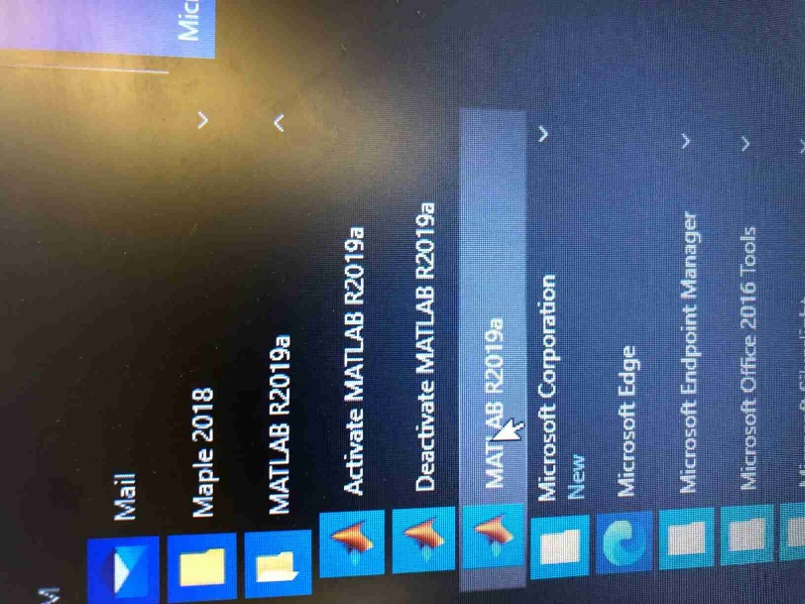

The other equipment you will need

Now you will need to make sure you have a signal to test, and some wires to get the signal into the myDAQ block. I tend to have another computer open to look for help online or to watch related videos. I use the oscilloscope to make sure I can measure my input with a second instrument just in case my data acquisition code is not doing something I expect. I use the function generator to produce sine wave voltages. Here is a photo of the setup I had going in lab.

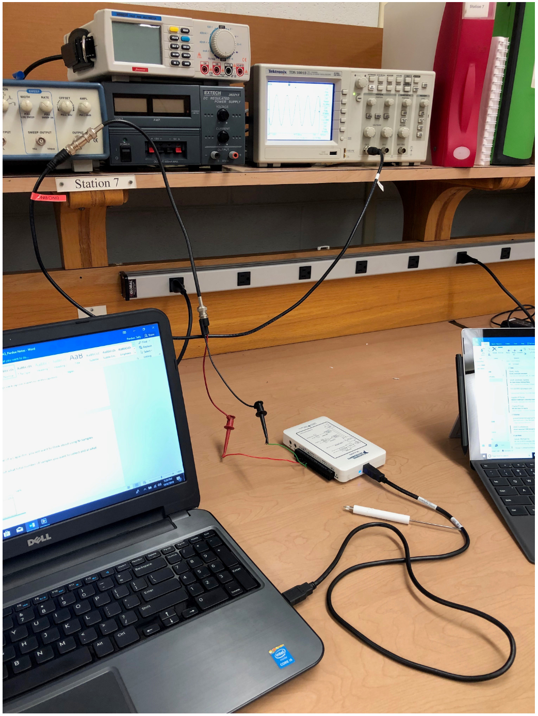

Wiring into the myDAQ

There is a screw terminal on the side of the myDAQ block. Please use the small screwdriver with NI lettering to try turning the screws to see how the terminal block works.

The input on the analog channel 0 needs to be setup as “differential” which means you need to the input signal’s (output from the function generator) “positive” lead to the positive 0+ and negative lead to the 0- and then ALSO run a connector wire from 0- to AIGRND. See image below.

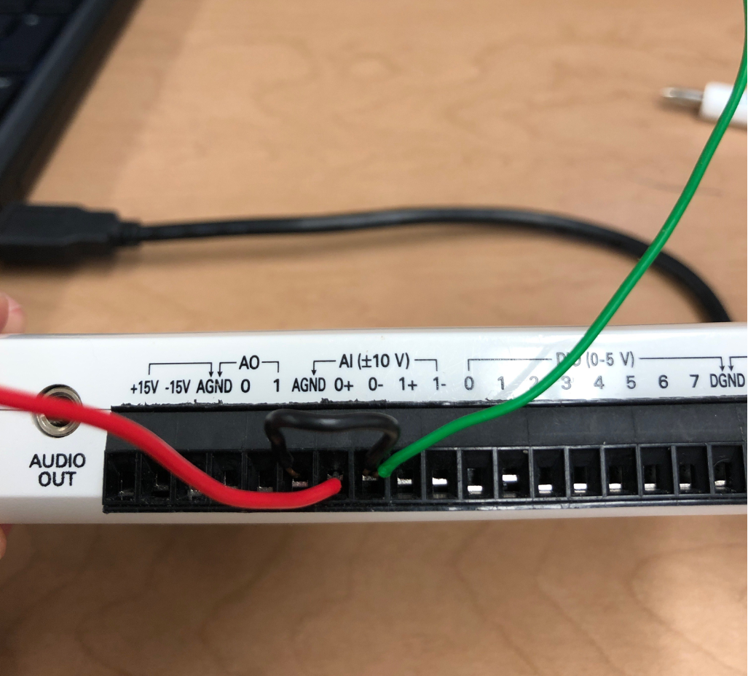

Now you can follow the steps of the MATLAB training to Get Started.

**Temperature Sensors TMP36 Information:**

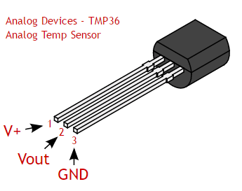

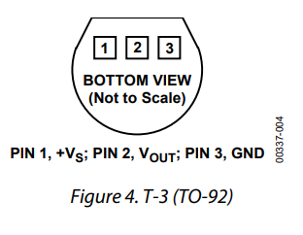

Bosch MAP Sensor Wiring

The following information is provided in the datasheet from Bosch for their MAP Sensors. Review the actual datasheet for more details.

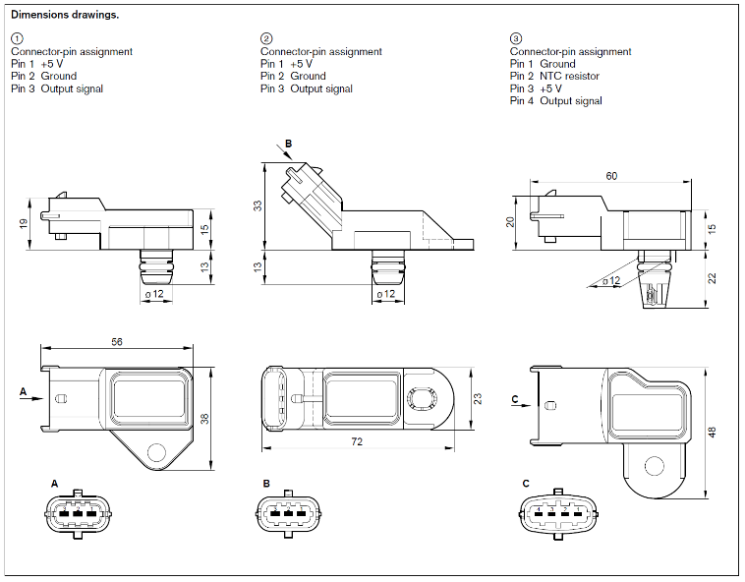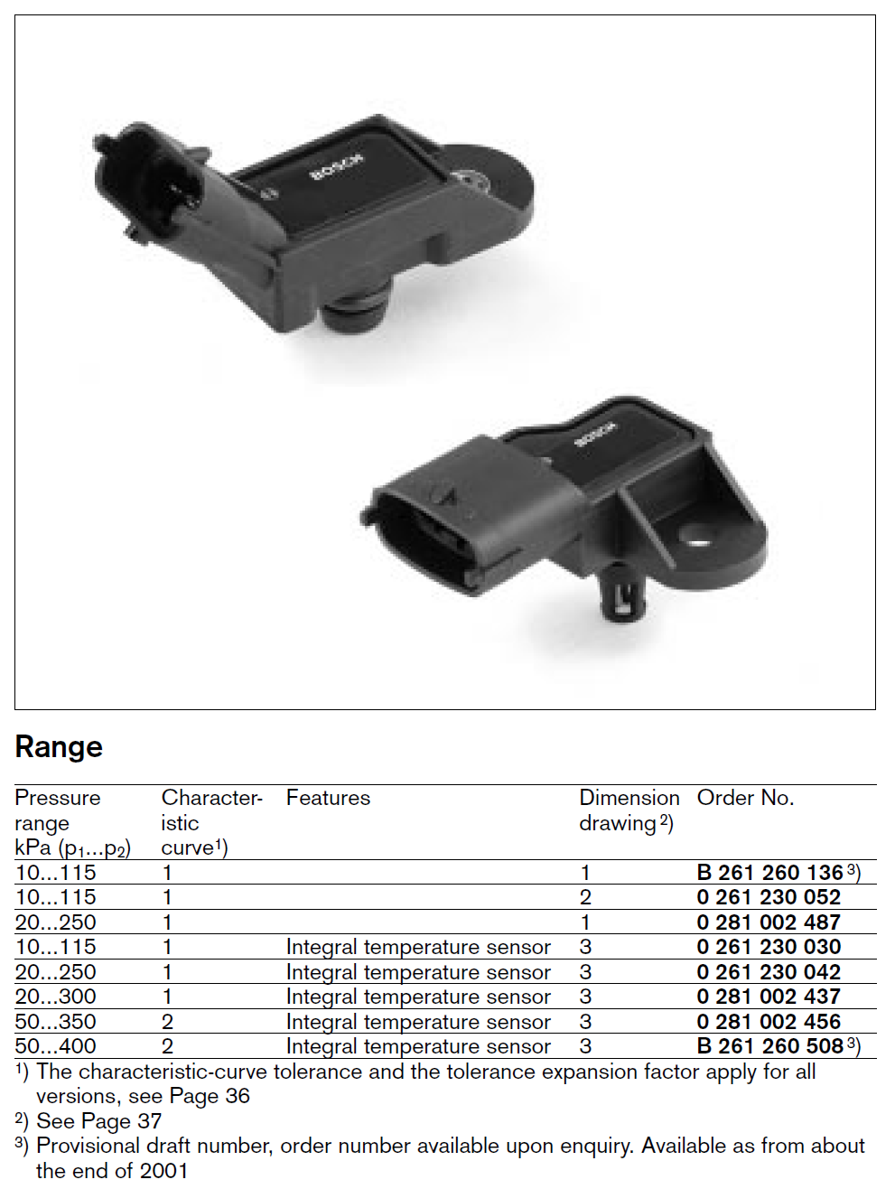

Considering the information from the datasheet, the following image shows the proper wiring of our Bosch 0 261 230 042 sensor. The NI myDAQ has a built-in 5V power supply that we will use to power the sensor. Note, an extra “jumper wire” is needed between the AI 0- and the AGND pin in order to provide a reference (ground) for the measurement. This is because the ground wire for the sensor has been wired to the myDAQ power supply’s ground (DGND).



Mityvac Hand Pump for Vacuum/Pressure

You will use a Mityvac hand pump to pressurize the pressure manifold during your static calibration. Note that the pump has a switch near the output barb that allows you to switch between generating pressure and generating vacuum. Be sure to turn the switch **all the way to pressure** in order to not have any internal leaks when you are trying to hold a static pressure in your manifold.

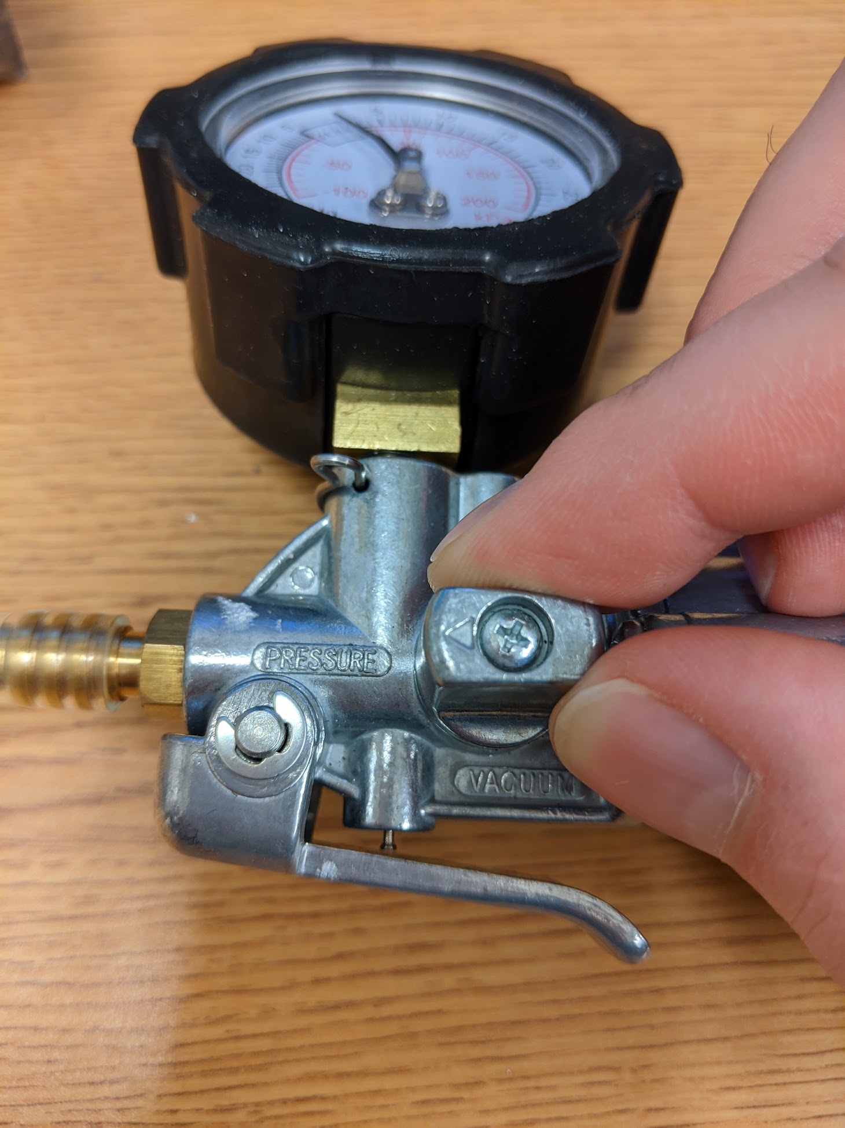

Overall Experimental Setup

The following provide a photo of the overall experimental setup showing the pressure manifold, the Bosch MAP sensor, the Dwyer digital pressure gage, the NI myDAQ, and the Mityvac hand pump.

